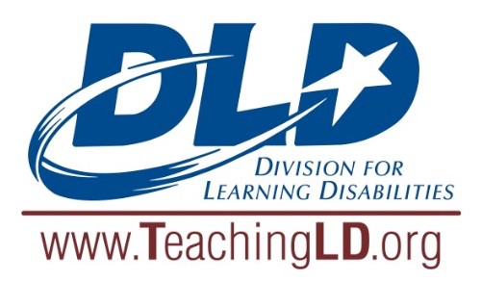 | DIVISION FOR LEARNING DISABILITIES  Marva Collins  Diversity Award

The Division for Learning Disabilities’ Marva Collins Diversity Award honors a special education teacher who makes a significant impact in the education field of children and youths with learning disabilities who come from culturally and linguistically diverse backgrounds. Nominators must be members of DLD.
The award consists of
- A $200 stipend,
- Up to $500 in travel expenses for presentation of the award held at DLD’s business meeting during CEC’s annual convention, and
- A commemorative plaque.
Timeline Nominations are due October 15 annually.
Nominations Please submit one nomination letter describing the nominee’s contributions. Please also provide the following information:
 | Nominee | Nominator
Name:
Address:
Phone:
e-mail:
Nominator’s DLD (CEC) member number:

References: In addition to the information requested above, please list two individuals who support this nomination. These references do not need to submit a letter, but they may be contacted as part of the selection process.
Visit TeachingLD.org for additional information about this and other initiatives of the Division for Learning Disabilities!
 | Reference #1 |  | Reference #2
Name:
Phone:
e-mail:

Email applications to:
DLD Cultural and Linguistic Diversity Committee Chair Peishi Wang: Diversity@TeachingLD.org.

