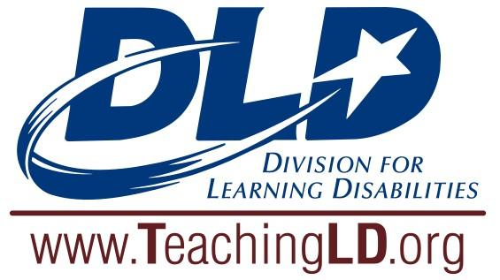

Candace S. Bos
Innovative Project Grant

The Division for Learning Disabilities’ (DLD) Bos Award is named after Candace S. Bos, a dedicated scholar who also served as president of DLD. These grants support doctoral students, teachers, and other pupil services personnel who provide services to students with learning disabilities as they develop creative projects to enhance instruction, curriculum, action research, and service delivery. DLD allots a total of $5,000 yearly, funding individual projects from $100 to $1,000. Applicants must be members of DLD. Applications are due October 15 annually.

Top of Form
Applicant name: | Applicant e-mail:
Applicant phone #: | Alternate Phone #:
CEC/DLD membership #: | Budget request:
Title of proposed project:
Date of the application: | Date(s) of the project:
Number of students with LD served by the project: | Grade level(s): | Content area:
School site for project:
School site mailing address: School mailing address:
Bottom of Form

Written Project Proposal: Please respond with the information requested below. Please do not list any names or other identifying information in your proposal.
The written project proposal should address the following:
- Project Description
- Project overview (based on validated research supported practices)
- Target population (disability and grade)
- Setting (school, community)
- Collaborators (families, businesses, agencies, colleagues, universities)
- Goals and Objectives: Intended, measurable student outcomes
- Timeline for Project Implementation
- Start and end dates
- Date by which final report will be submitted
4. Evaluation tools to be used
5. Budget Request
- List each item separately with cost
- Requested items should match goals and objectives
- Additional Funds
- Explain if matching or additional funds are available for this project

Guidelines
- Innovative Project Grants up to $1,000 will be awarded.
- Doctoral students, teachers, students, and support personnel are eligible to apply.
- Grants will be awarded to DLD members only.

Top of Form
Partial Funding:
☐ I am willing to accept partial funding
☐ I am NOT willing to accept partial funding
Applicant signature: Date:
Supervisor/Advisor signature: Date:
Bottom of Form
Grant funds may be used to purchase equipment or provide field trips, but not when these are an end in themselves. Equipment and trips need to be a component in a well-planned unit of instruction. Grant recipients must submit a final report summarizing the implementation with the budget and outcomes of the project. If pictures of students are included, please attach parent consent for the use of the picture. The Professional Development Standards and Ethics (PDSE) Committee will submit the summary to DLD for publication. Grantees may use the outcomes for submission to regional and national conferences.

Applications are due October 15 annually. Send questions and applications to Dr. Elizabeth M. Hughes at emh71@psu.edu. Email response will be sent upon receipt.
Visit TeachingLD.org for additional information about this and other initiatives of the Division for Learning Disabilities!

